MTE 544 A1

Joseph Lundy 20514551

Jacob Rampertab 20506372

Group 16

# 1 Derivation of Motion Model

Based on the instantaneous center of zero velocity model for a wheel, the magnitude of the velocity of each wheel’s center is simply $rω$

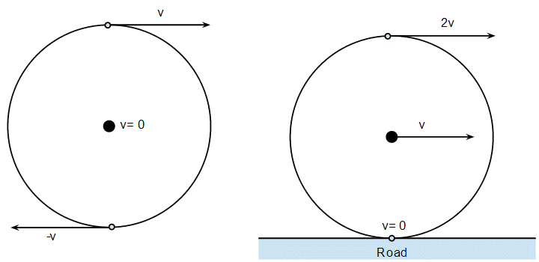

$$v_{1}=rω_{1};v_{2}=rω_{2};v_{3}=rω_{3}$$

Transposing velocity vectors to the center of robot

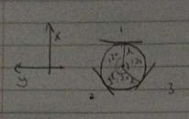

$${\vec{v}}_{robot frame}={\vec{v}}_{1}+{\vec{v}}_{2}+{\vec{v}}_{3}$$

$${\dot{θ}}_{c}={\dot{θ}}_{1}+{\dot{θ}}_{2}+{\dot{θ}}_{3}$$

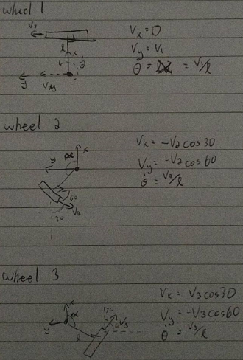

The net vx , vy with respect to the robot’s frame of reference given by:

$$v_{robot x}=\left(v_{3}-v_{2}\right)\cos{{30}^{o}=r(ω_{3}-ω_{2})}\cos{{30}^{o}}$$

$$v_{robot y}=v_{1}-\left(v_{3}+v_{2}\right)\cos{{60}^{o}=r{(ω}_{1}-\left(ω_{2}+ω_{3}\right))}\cos{{30}^{o}}$$

Vx and Vy with respect to the absolute coordinate frame given by:

$$\dot{x}=v_{robot x}*\cos\left(θ\right)-v_{robot y}*sin⁡(θ)$$

$$\dot{y}=v_{robot x}*\sin\left(θ\right)+v_{robot y}*cos⁡(θ)$$

X and Y position given by:

$$x=x_{t-1}+dt \dot{x}$$

$$y=y_{t-1}+dt \dot{y}$$

Angular velocity given by: $\dot{θ}=\frac{r}{l}(ω_{1}+ω_{2}+ω_{3})$

Angular position given by $θ_{t}=θ_{t-1}+dt \dot{θ}$

Input and state vectors are:

$U=\left[\begin{matrix}ω_{1} \\ ω_{2} \\ ω_{3}\end{matrix}\right]$; $X=\left[\begin{matrix}x_{1} \\ x_{2} \\ x_{3}\end{matrix}\right]=\left[\begin{matrix}x_{t} \\ y_{t} \\ θ_{t}\end{matrix}\right]$

Full state equation with disturbances given by:

$$\left[\begin{matrix}x_{t} \\ y_{t} \\ θ_{t}\end{matrix}\right]= g\left(X,U\right)+ε_{t}$$

$$g(X,U)=\left[\begin{matrix}x_{t-1}+dt\left(v_{robot x}*\cos\left(θ\right)-v_{robot y}*\sin\left(θ\right)\right) \\ y_{t-1}+dt\left(v_{robot x}*\sin\left(θ\right)+v_{robot y}*\cos\left(θ\right)\right) \\ θ_{t-1}+dt\left(\frac{r}{l}(ω_{1}+ω_{2}+ω_{3})\right)\end{matrix}\right]$$

$$ε_{t}=\left[\begin{matrix}N(0, 0.01) \\ N(0, 0.01) \\ N(0, 0.1)\end{matrix}\right]$$

Where x-y velocities in the robot frame are:

$$v_{robot x}=\left(v_{3}-v_{2}\right)\cos{{30}^{o}=r(ω_{3}-ω_{2})}\cos{{30}^{o}}$$

$$v_{robot y}=v_{1}-\left(v_{3}+v_{2}\right)\cos{{60}^{o}=r{(ω}_{1}-\left(ω_{2}+ω_{3}\right))}\cos{{60}^{o}}$$

# 2 Robot Simulation

The following values were found to produce the requested motion from the robot. To complete the expanding spiral, updating of one of the velocities was necessary. The velocity of wheel one slowly decreases through the iterations of the main loop to complete an expanding spiral.

|  |  |  |  |
| --- | --- | --- | --- |
| $ω_{1}$ (rad/s) | $ω_{2}$ (rad/s) | $ω_{3}$ (rad/s) | Graph |
| 5.5 | -5 | 2.25 | Drives in a circle with diameter 2 m |
| 0 | -1 | 1 | Drives in straight line |
| 8-0.05*t | -3 | 3 | Drives in expanding spiral |

The following graphs were generated using the motion model and the values from the table above. In order, they show the robot driving in an approximate two meter diameter circle, a straight line, and an expanding spiral while including the effects of the disturbances on the robot.

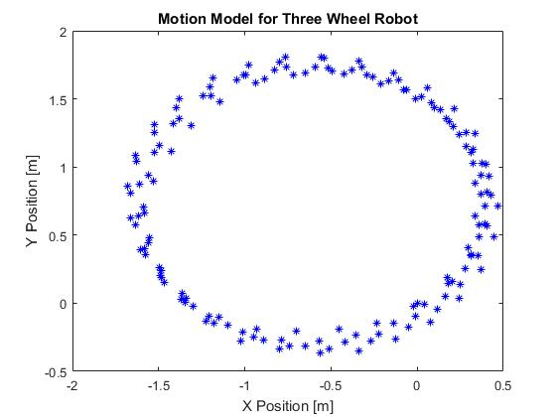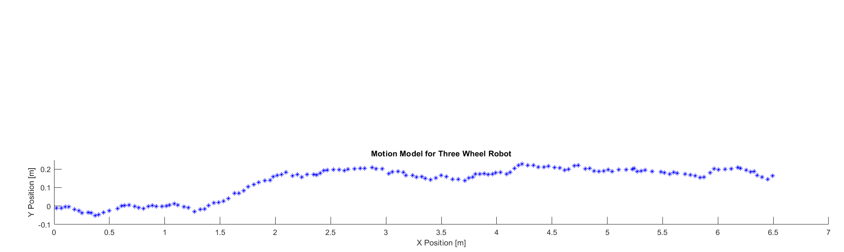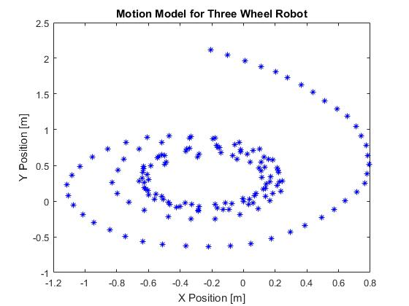

# 3 Measurement Model

The measurement model was defined as the three inputs from the sensors, being the global x and y positions from the GPS and the orientation from the magnetometer. The magnetometer values is also adjusted to true north to match that of the GPS. Disturbances were added as specified.

$$Y=\left[\begin{matrix}y_{1} \\ y_{2} \\ y_{3}\end{matrix}\right]=h\left(x,u\right)+ε;$$

$h\left(x\right)=\left[\begin{matrix}x \\ y \\ θ+\frac{9.7π}{180}\end{matrix}\right]$

$ε=\left[\begin{matrix}N(0,0.5) \\ N(0,0.5) \\ N(0,\frac{10π}{180})\end{matrix}\right]$

# 4 Define Extended Kalman Filter

The Extended Kalman Filter was defined using the following matricies and the equations of motion and measurement from the previous two sections.

## Deriving G

$$g(\overline{μ},u_{t})=\left[\begin{matrix}x_{t-1}+dt\left(v_{robot x}*\cos\left(θ\right)-v_{robot y}*\sin\left(θ\right)\right) \\ y_{t-1}+dt\left(v_{robot x}*\sin\left(θ\right)+v_{robot y}*\cos\left(θ\right)\right) \\ θ_{t-1}+dt\left(\frac{r}{l}(ω_{1}+ω_{2}+ω_{3})\right)\end{matrix}\right]$$

$$G\left(\overline{μ},u_{t}\right)=\frac{∂}{∂x}g{\left(\overline{μ},u_{t}\right)}_{|(μ_{t-1},u)}=\left[\begin{matrix}1 & 0 & dt\left(-v_{robot x}*\sin\left(θ\right)-v_{robot y}*\cos\left(θ\right)\right) \\ 0 & 1 & dt\left(v_{robot x}*\cos\left(θ\right)-v_{robot y}*\sin\left(θ\right)\right) \\ 0 & 0 & 1\end{matrix}\right]$$

## Deriving H

$h\left(x\right)=\left[\begin{matrix}x \\ y \\ θ+\frac{9.7π}{180}\end{matrix}\right]$

$H\left(x,u\right)=\frac{∂}{∂x} h{\left(x\right)}_{|(μ_{t-1},u)}=\left[\begin{matrix}1 & 0 & 0 \\ 0 & 1 & 0 \\ 0 & 0 & 1\end{matrix}\right]$

## Deriving R, Q, Qcorrected

# 5 Implement Extended Kalman Filter

The equations were then implemented and plotted against the motion and measurement models. The following graphs show the result of the tracking using the provided inputs. The belief vs the real motion is also plotted over all cycles. The video of generation for the first figure is ekf.avi.

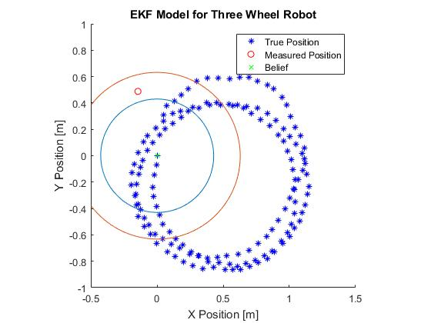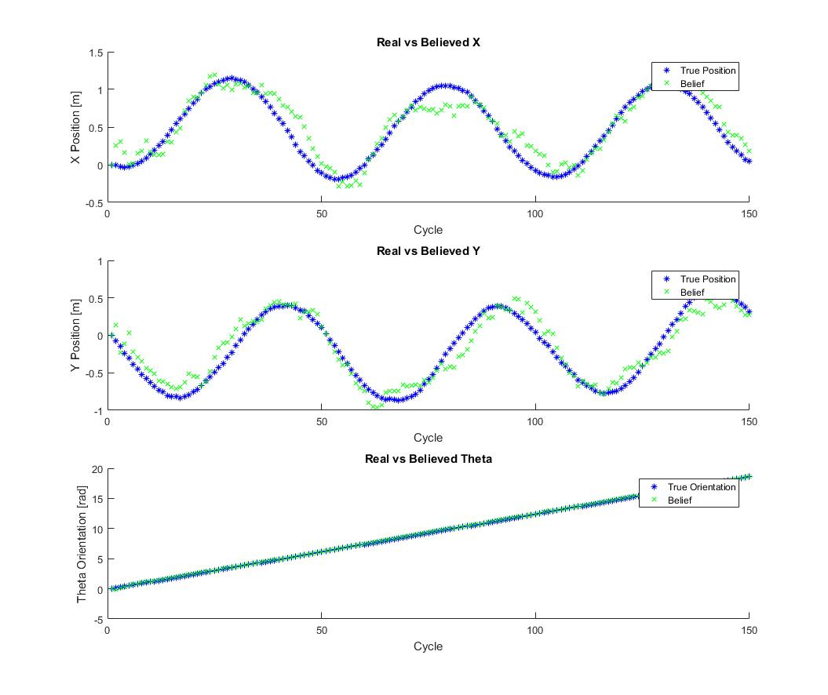

# 6 Implement Multi-Extended Kalman Filter

The original EKF model was adjusted to incorporate the correction input for GPS at 1Hz using the Multi-Kalman Filter process. Every 10th cycle, the corrected input is taken in and a different Q matrix, Qcorrected, is used to calculate the Kalman gain. The results are plotted in the following two images. In the real vs belief plots, the belief follows the actual much closer and can be seen visibly correcting every 10 cycles. The error ellipses are also smaller for this version of the filter than in the previous section. The video of generation for the first figure is multi_ekf.avi.

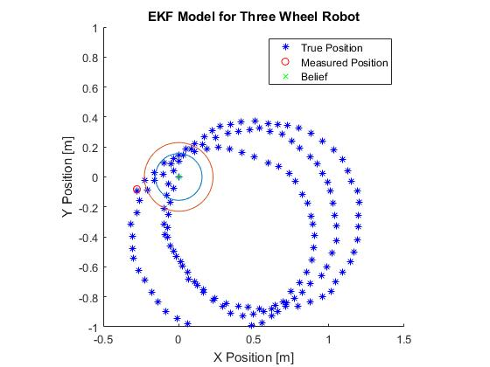

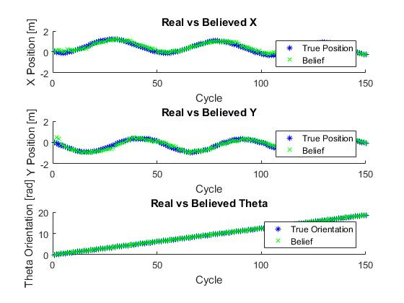

# Code

The code for the graphs in this report can be found as a part of the zipped submission. Question 1 and 2 are completed using motion_model.m. Question 3 is done using full_model.m. Questions 4, 5, and 6 are completed using model_ekf.m and adjusting the input parameters within the file as described in the description.